

**ONLINE DOCTOR APPOINTMENT**

**PROJECT Report For**

**OPEN SOURCE PROGRAMMING LAB (SWE408)**

**INTERNAL EVALUATION**

***BY***

**L.H.SWAROOP - ( 13MSE0083 )**

**D.KANNAN - (13MSE0111)**

**OF**

**M.S.(Software Engineering) 3rd Year**

**TO**

**Prof. PRIYA V.**

**Assistant Professor(Senior)**

**INTERNAL EXAMINER EXTERNAL EXAMINER**

**TABLE OF CONTENTS**

|  |  |
| --- | --- |
| **CHAPTERS** | **PAGE** |
| **1.ABSTRACT** | **1** |
| **2.INTRODUCTION** | **1** |
| **3.MOTIVATION** | **1** |
| **4.REQUIREMENTS** | **2** |
| **5.MODULES** | **2-3** |
| **6.CODING** | **4-34** |
| **7.SNAPSHOTS** | **35-39** |
| **8.CONCLUSION** | **40** |

**ABSTRACT:-**

**It’s very difficult to consult the professional Doctor in big hospitals. So, we need an appointment to consult the Doctors. Going to the Hospital and get the appointment is very difficult sometimes. And some people don’t know whom to consult for their health problem. So, you can know the departments of the doctor to consult according to the selected date and time.**

**INTRODUCTION:-**

**DOCTER ONLINE APPOINTMENT is an application which is used to make an appointment to the doctor according to their needed date and their wish. It will help to make an appointment very easily on their chosen date. And a doctor can also see his/her appointments with the date chosen by the patient.**

**MOTIVATION:-**

**The main motivation of this application is to get the appointment on online based on the selected date for the particular Doctor.By this wasting of time in the hospitals can be saved people can book their appointments.**

**The Doctors appointment availability status and their information can be view by using this application.**

**The Doctor has to know the patient details very easily who are registered for their slot.**

**REQUIREMENTS**

**HARDWARE REQUIREMENTS:**

A Computer

RAM - Min. 1 GB

HDD - 50 GB

**SOFTWARE REQUIREMENTS:**

WAMP/LAMP Server

SQL database

Web browser

Windows OS / Linux

**PROJECT DISCRIPTION**

**MODULES**

**Module1:**

**First a user need to register with username, password and valid email , phone number.**

**Module2:**

**Login with registered user name and password to log in and make an appointment.**

**Module3:**

**User can make an appointment according to which doctor they chose to attend with particular department and date.**

**Module4:**

**Need to select the slot and timing to book and mandatory to fill the patient detai1s with simple description.**

**After that it generates the outpatient’s id with booked Doctor details and by submitting it will be the appointment has been successful.**

**MODULE5:**

**Doctor can get the information about appointments and patient details.**

**SOURCE CODE**

**loginud.php**

<html>

<style type="text/css">

body{

background: url("1.jpg")no-repeat center center fixed;-moz-background-size: cover;

-webkit-background-size: cover;

-o-background-size: cover;

background-size: cover; }

.animate{

transition: all 0.1s;-webkit-transition: all 0.1s;}

.action-button{

position: relative;

padding: 10px 40px;

margin: 0px 10px 10px 0px;

float: left;

border-radius: 10px;

font-family: 'Pacifico', cursive;

font-size: 25px;

color: #FFF;

text-decoration: none;

}

.blue

{

background-color: #3498DB;

border-bottom: 5px solid #2980B9;

text-shadow: 0px -2px #2980B9;

}

.bluee

{

background-color: #3498DB;

border-bottom: 5px solid #2980B9;

text-shadow: 0px -2px #2980B9;

left:400px;

}

.red

{

background-color: #E74C3C;

border-bottom: 5px solid #BD3E31;

text-shadow: 0px -2px #BD3E31;

}

#div5{position:absolute;

width:1349px;

height:120px;

top:400px;

color:darkblue;

}

</style>

<body>

<h1 class="action-button shadow animate bluee" style="font-style:italic;" align="center"><font >ONLINE DOCTER APPOINTMENT</font></h1><br><br> <br> <br><br>

<a href="userlogin.php" class="action-button shadow animate blue">User login</a><br><br> <br> <br><br>

<a href="doctorlogin.php" class="action-button shadow animate blue">Doctor login</a>

<div id="div5">

<pre> <h1>

->Book Appointment in online<br>

->Fast Appointment Booking<br>

->Simple And Faster</h1></pre>

</div>

</body>

</html>

**Userlogin.php**

<html>

<style type="text/css">

body{

background-image: url("surgeons-bg.jpg");

color:white;

}

.wi{

padding-left: 80px;

}

.set{

width:30%;

}

.wd{

color:white;

}

</style>

<body >

<center>

<h3 align="center">ONLINE DOCTER APPOINTMENT</h3>

<fieldset class="set"><legend class="title"><h2>User login</h2></legend>

<form method="POST" action="">

<table border="0" align="center" >

<tr>

<td>Username</td>

<td><input type="text" name="uname">

</td></tr>

<tr><td>Password</td>

<td><input type="password" name="pass"</td>

</tr><tr><td class="wi" ><img src="captcha1.php" id="capt"></td>

</tr><tr><td>Enter verification code</td>

<td><input type="text" name="t1" maxlength="5"></td>

</tr><tr><!--<td><input type="checkbox" name="check" id="remember" value="remember"</td>Remember Password-->

</tr><tr><td></td><td align="left"><input type="submit" name="Login" value="login"></td>

</tr><td><a href="registration1.php" class="wd">New User</a></td>

<td><a href="reset4.php" class="wd">Forget password</a></td>

</table></form>

</tr></fieldset>

</center>

<?php

session_start();

include('db.php');

function phpAlert($msg) {

echo '<script type="text/javascript">alert("' . $msg . '")</script>';

}if(isset($_POST['Login']))

{$uname=$_POST['uname'];

$password=$_POST['pass'];

if($uname!=''&&$password!='')

{$query10="SELECT * from form1 where username ='".$uname."' and password = '".$password."'";

$result=mysqli_query($con,$query10);

$res=mysqli_fetch_assoc($result);

if ($res){

if($_POST['t1']!=''){

if($_POST['t1']==$_SESSION['my_captcha']){

$_SESSION['username']=$uname;

header('location:welcomecopy.php');

}else{

$msg="Enter correct verification code";

phpAlert( $msg );

}} else{

$msg="Enter verification code";

phpAlert( $msg );

}}else

{ $msg="Enter correct details";

phpAlert( $msg );

}}else

{$msg="Enter the details";

phpAlert( $msg );

}}

?></body></html>

**confirm.php**

<html><style type="text/css">

body{

background: url("rt.jpg")no-repeat center center fixed;

-moz-background-size: cover;

-webkit-background-size: cover;

-o-background-size: cover;

background-size: cover;

}</style>

<body>

<?php

session_start();

$con = mysqli_connect("localhost","root", "", "form");

if (!$con){

die('Could not connect: ' . mysqli_error());

exit(); }

$b1=$_SESSION['name']; $b2=$_SESSION['uname'];$b3=$_SESSION['pwd'];

$b4=$_SESSION['ph']; $b5=$_SESSION['email']; $b6=$_SESSION['gender'];

$b7=$_SESSION['comment']; $sql="INSERT INTO form1 VALUES ('$b1','$b2','$b3',$b4,'$b5','$b6','$b7')";

$result=mysqli_query($con,$sql);

if($result){

echo "<h2>Updated Successfully</h2>";}

else{

echo "Update Failed";

}

?>

</body>

</html>

**welcomecopy.php**

<html>

<!DOCTYPE html>

<!--[if lt IE 7]> <html class="lt-ie9 lt-ie8 lt-ie7" lang="en"> <![endif]-->

<!--[if IE 7]> <html class="lt-ie9 lt-ie8" lang="en"> <![endif]-->

<!--[if IE 8]> <html class="lt-ie9" lang="en"> <![endif]-->

<!--[if gt IE 8]><!--> <html lang="en"> <!--<![endif]-->

<head>

<meta charset="utf-8">

<meta http-equiv="X-UA-Compatible" content="IE=edge,chrome=1">

<!--[if lt IE 9]><script src="//html5shim.googlecode.com/svn/trunk/html5.js"></script><![endif]-->

<Script type="text/javaScript">

function state()

{

var sel=document.form1.d11.value;

alert("you seleccted "+sel);

if(sel == "cardiology"){

document.form1.l2.disabled = false;

document.form1.l3.disabled = true;

document.form1.l4.disabled = true;

}

else if(sel == "orthopedics")

{

document.form1.l3.disabled = false;

document.form1.l2.disabled = true;

document.form1.l4.disabled = true;

}

else{

document.form1.l4.disabled = false;

document.form1.l2.disabled = true;

document.form1.l3.disabled = true;

}

}

</Script>

</head>

<style type="text/css">

body

{

background: url("67.jpg")no-repeat center center fixed;

-moz-background-size: cover;

-webkit-background-size: cover;

-o-background-size: cover;

background-size: cover;

color:white;

font: 13px/20px "Lucida Grande", Tahoma, Verdana, sans-serif;

}

#tes {

font-size: 20px;

}

.contain{

}

.container {

margin: 80px auto;

width: 400px;

text-align: center;

}

.container > .dropdown {

margin: 0 20px;

vertical-align: top;

}

.dropdown {

display: inline-block;

position: relative;

overflow: hidden;

height: 28px;

width: 150px;

background: #f2f2f2;

border: 1px solid;

border-color: white #f7f7f7 whitesmoke;

border-radius: 3px;

background-image: -webkit-linear-gradient(top, transparent, rgba(0, 0, 0, 0.06));

background-image: -moz-linear-gradient(top, transparent, rgba(0, 0, 0, 0.06));

background-image: -o-linear-gradient(top, transparent, rgba(0, 0, 0, 0.06));

background-image: linear-gradient(to bottom, transparent, rgba(0, 0, 0, 0.06));

-webkit-box-shadow: 0 1px 1px rgba(0, 0, 0, 0.08);

box-shadow: 0 1px 1px rgba(0, 0, 0, 0.08);

}

.dropdown:before, .dropdown:after {

content: '';

position: absolute;

z-index: 2;

top: 9px;

right: 10px;

width: 0;

height: 0;

border: 4px dashed;

border-color: #888888 transparent;

pointer-events: none;

}

.dropdown:before {

border-bottom-style: solid;

border-top: none;

}

.dropdown:after {

margin-top: 7px;

border-top-style: solid;

border-bottom: none;

}

.dropdown-select {

position: relative;

width: 130%;

margin: 0;

padding: 6px 8px 6px 10px;

height: 28px;

line-height: 14px;

font-size: 12px;

color: #62717a;

text-shadow: 0 1px white;

background: #f2f2f2; /* Fallback for IE 8 */

background: rgba(0, 0, 0, 0) !important; /* "transparent" doesn't work with Opera */

border: 0;

border-radius: 0;

-webkit-appearance: none;

}

.dropdown-select:focus {

z-index: 3;

width: 100%;

color: #394349;

outline: 2px solid #49aff2;

outline: 2px solid -webkit-focus-ring-color;

outline-offset: -2px;

}

.dropdown-select > option {

margin: 3px;

padding: 6px 8px;

text-shadow: none;

background: #f2f2f2;

border-radius: 3px;

cursor: pointer;

}

.lt-ie9 .dropdown {

z-index: 1;

}

.lt-ie9 .dropdown-select {

z-index: -1;

}

.lt-ie9 .dropdown-select:focus {

z-index: 3;

}

@-moz-document url-prefix() {

.dropdown-select {

padding-left: 6px;

}

}

.dropdown-dark {

background: #444;

border-color: #111111 #0a0a0a black;

background-image: -webkit-linear-gradient(top, transparent, rgba(0, 0, 0, 0.4));

background-image: -moz-linear-gradient(top, transparent, rgba(0, 0, 0, 0.4));

background-image: -o-linear-gradient(top, transparent, rgba(0, 0, 0, 0.4));

background-image: linear-gradient(to bottom, transparent, rgba(0, 0, 0, 0.4));

-webkit-box-shadow: inset 0 1px rgba(255, 255, 255, 0.1), 0 1px 1px rgba(0, 0, 0, 0.2);

box-shadow: inset 0 1px rgba(255, 255, 255, 0.1), 0 1px 1px rgba(0, 0, 0, 0.2);

}

.dropdown-dark:before {

border-bottom-color: #aaa;

}

.dropdown-dark:after {

border-top-color: #aaa;

}

.dropdown-dark .dropdown-select {

color: #aaa;

text-shadow: 0 1px black;

background: #444; /* Fallback for IE 8 */

}

.dropdown-dark .dropdown-select:focus {

color: #ccc;

}

.dropdown-dark .dropdown-select > option {

background: #444;

text-shadow: 0 1px rgba(0, 0, 0, 0.4);

}

#div2{

position:absolute;

width:1349px;

height:px;

border:1px;

top:230px;

}

.button_example{

border-color:#D1D1D1;border-width: 1px 1px 5px 1px;border-style: solid; -webkit-border-radius: 11px; -moz-border-radius: 11px;border-radius: 11px;font-size:17px;font-family:comic sans, comic sans ms, cursive, verdana, arial, sans-serif; padding: 10px 10px 10px 10px; text-decoration:none; display:inline-block;text-shadow: 1px 1px 0 rgba(255,255,255,1);font-weight:bold; color: #242424;

background-color: #F9F9F9; background-image: -webkit-gradient(linear, left top, left bottom, from(#F9F9F9), to(#B0B0B0));

background-image: -webkit-linear-gradient(top, #F9F9F9, #B0B0B0);

background-image: -moz-linear-gradient(top, #F9F9F9, #B0B0B0);

background-image: -ms-linear-gradient(top, #F9F9F9, #B0B0B0);

background-image: -o-linear-gradient(top, #F9F9F9, #B0B0B0);

background-image: linear-gradient(to bottom, #F9F9F9, #B0B0B0);filter:progid:DXImageTransform.Microsoft.gradient(GradientType=0,startColorstr=#F9F9F9, endColorstr=#B0B0B0);

}

.button_example:hover{

border-color:#B5AEA8;border-width: 1px 1px 5px 1px;border-style: solid;

background-color: #E0E0E0; background-image: -webkit-gradient(linear, left top, left bottom, from(#E0E0E0), to(#979797));

background-image: -webkit-linear-gradient(top, #E0E0E0, #979797);

background-image: -moz-linear-gradient(top, #E0E0E0, #979797);

background-image: -ms-linear-gradient(top, #E0E0E0, #979797);

background-image: -o-linear-gradient(top, #E0E0E0, #979797);

background-image: linear-gradient(to bottom, #E0E0E0, #979797);filter:progid:DXImageTransform.Microsoft.gradient(GradientType=0,startColorstr=#E0E0E0, endColorstr=#979797);

}

</style>

<body>

<h2 align="center">ONLINE DOCTER APPOINTMENT</h2>

<h2 align="center">Visiting hours is between 6 to 9p.m</h2>

<div id="tes">

<?php

session_start();

$name=$_SESSION['username'];

echo "Welcome: ".$name."<br>";

?>

</div>

<form name="form1" method="POST" action="confirm2.php" align="center">

<h2 >Please select department and doctor</h2>

<div class="dropdown">

<Select name="d11" onChange="state()" class="dropdown-select">

<option value="-1" >------Department ------</option>

<option value="cardiology" >Cardiology</option>

<option value="orthopedics" >orthopedics</option>

<option value="cancer" >cancer</option>

</Select>

</div>

<div class="dropdown">

<Select name="l2" class="dropdown-select">

<option value="-1" >------Cardiology ------</option>

<option value="siddharth"> siddharth</option>

<option value="sweatha"> sweatha</option>

<option value="manoj">manoj </option>

<option value="koushik">koushik </option>

<option value="daniel">daniel </option>

</Select>

</div>

<div class="dropdown">

<Select name="l3" class="dropdown-select">

<option value="-1" >------orthopedics ------</option>

<option value="bharath">bharath </option>

<option value="kannan">kannan </option>

<option value="ambika">ambika</option>

<option value="janani">jananni </option>

<option value="kishore">kishore</option>

</Select>

</div>

<div class="dropdown" >

<Select name="l4" class="dropdown-select">

<option value="-1" >------cancer ------</option>

<option value="vinod">vinod</option>

<option value="ranjith">ranjith </option>

<option value="shalini">shalini </option>

<option value="geetha">geetha </option>

<option value="rajesh">rajesh</option>

</Select>

</div>

<h2 >Please select date and time</h2>

<div class="dropdown" >

<select name="date1" class="dropdown-select">

<option value="1" > 1 </option>

<option value="2" > 2 </option>

<option value="3" > 3 </option>

<option value="4" > 4 </option>

<option value="5" > 5 </option>

<option value="6" > 6 </option>

<option value="7" > 7</option>

<option value="8" > 8 </option>

<option value="9" > 9 </option>

<option value="10" > 10</option>

<option value="11" > 11 </option>

<option value="12" > 12</option>

<option value="13" > 13 </option>

<option value="14" > 14 </option>

<option value="15" > 15 </option>

<option value="16" > 16</option>

<option value="17" > 17 </option>

<option value="18" > 18</option>

<option value="19" > 19 </option>

<option value="20" > 20 </option>

<option value="21" > 21 </option>

<option value="22" > 22 </option>

<option value="23" > 23</option>

<option value="24" > 24 </option>

<option value="25" > 25</option>

<option value="26" > 26 </option>

<option value="27" > 27</option>

<option value="28" > 28 </option>

<option value="29" > 29 </option>

<option value="30" > 30 </option>

<option value="31" > 31</option>

</select>

</div>

<div class="dropdown" >

<select name="month1" class="dropdown-select" >

<option value="jan" > january </option>

<option value="feb" > febrauary </option>

<option value="mar" > march </option>

<option value="apr" > april </option>

<option value="may" > may </option>

<option value="jun" > june </option>

<option value="jul" > july </option>

<option value="aug" > august</option>

<option value="sep" >september </option>

<option value="oct" > October </option>

<option value="nov" > November </option>

<option value="dec" > December </option>

</select>

</div>

<div class="dropdown" >

<select name="year1" class="dropdown-select">

<option value="2016" > 2016 </option>

<option value="2017" > 2017 </option>

<option value="2018" > 2018 </option>

</select>

</div> <br>

<br>

<br>

<h2 align="center">Press 'confirm' to make appointment</h2>

<input type="submit" class="button_example" name="confirm" value="confirm">

</body>

</html>

**doctorlogin.php**

<html>

<style type="text/css">

body

{

background: url('9.jpg') no-repeat center center fixed;

-moz-background-size: cover;

-webkit-background-size: cover;

-o-background-size: cover;

background-size: cover;

color:black;

}

.set{

width:30%;

}

</style>

<body >

<center>

<h3 align="center">ONLINE DOCTER APPOINTMENT</h3>

<fieldset class="set"><legend class="title"><h2>Doctor login</h2></legend>

<form method="POST" action="<?php echo $_SERVER['PHP_SELF']; ?>">

<table border="0" align="center" >

<tr>

<td>Username</td>

<td><input type="text" name="uname"></td>

</tr>

<tr>

<td>Password</td>

<td><input type="password" name="pass"</td>

</tr>

<tr>

<form type="post" action="captcha2.php">

<td align="center" ><img src="captcha1.php" id="capt"></td>

</tr>

<tr>

<td>Enter verification code</td>

<td><input type="text" name="t1" maxlength="5"></td>

</tr>

<tr>

<td></td><td align="left"><input type="submit" name="Login" value="login"</td>

</tr>

<!--<td><a href="<?php echo $_SERVER['PHP_SELF']; ?>">Forget password</a></td>-->

</table>

</form>

</tr>

</fieldset>

</center>

<?php

session_start();

include('db.php');

function phpAlert($msg) {

echo '<script type="text/javascript">alert("' . $msg . '")</script>';

}

if(isset($_POST['Login']))

{

$uname=$_POST['uname'];

$password=$_POST['pass'];

if($uname!=''&&$password!='')

{

$query10="SELECT * from doctor where username ='".$uname."' and password = '".$password."'";

$result=mysqli_query($con,$query10);

$res=mysqli_fetch_assoc($result);

if ($res)

{

if($_POST['t1']!=''){

if($_POST['t1']==$_SESSION['my_captcha']){

$_SESSION['username']=$uname;

header('location:welcomedl1.php');

}

else{

$msg="Enter correct verification code";

phpAlert( $msg );

}

} else{

$msg="Enter verification code";

phpAlert( $msg );

}

}

else

{

$msg="Enter correct details";

phpAlert( $msg );

}

}

else

{

$msg="Enter the details";

phpAlert( $msg );

}

}

?>

</body>

</html>

**confirm2.php**

<html>

<style type="text/css">

body

{

background: url("rt.jpg")no-repeat center center fixed;

-moz-background-size: cover;

-webkit-background-size: cover;

-o-background-size: cover;

background-size: cover;

}

</style>

<body>

<center>

<?php

session_start();

function phpAlert($msg) {

echo '<script type="text/javascript">alert("' . $msg . '")</script>';

}

$name=$_SESSION['username'];

$con = mysqli_connect("localhost","root", "", "form");

if (!$con)

{

die('Could not connect: ' . mysqli_error());

exit();

}

if(isset($_POST["confirm"])){

$b1=$_POST['d11'];

$b2=$_POST['date1'];

$b3=$_POST['month1'];

$b4=$_POST['year1'];

$b5=$b2."/".$b3."/".$b4;

$seldoct;

$d1= isset($_POST['l2'])? $_POST['l2']:'';

$d2=isset($_POST['l3'])? $_POST['l3']:'';

$d3=isset($_POST['l4'])? $_POST['l4']:'';

if($d1==null && $d2== null )

{

$seldoct=$d3;

$sql="INSERT INTO appointment (name,date,dept,doctor) VALUES ('".$name."','".$b5."','".$b1."','".$seldoct."')";

$result=mysqli_query($con,$sql);

if($result)

{

echo "<h3>Appointmemt made successfully</h3><br>";

echo "your selected department: ".$b1."<br>";

echo "your selected date: ".$b5."<br>";

echo "your selected doctor:".$seldoct."<br>";

}

else

{

echo "Appointment not made";

}

}

else if($d2==null && $d3== null )

{

$seldoct=$d1;

$sql="INSERT INTO appointment (name,date,dept,doctor) VALUES ('".$name."','".$b5."','".$b1."','".$seldoct."')";

$result=mysqli_query($con,$sql);

if($result)

{

echo "<h3>Appointmemt made successfully</h3><br>";

echo "your selected department: ".$b1."<br>";

echo "your selected date: ".$b5."<br>";

echo "your selected doctor:".$seldoct."<br>";

}

else

{

echo "Appointment not made";

}

}

else

{

$seldoct=$d2;

$sql="INSERT INTO appointment (name,date,dept,doctor) VALUES ('".$name."','".$b5."','".$b1."','".$seldoct."')";

$result=mysqli_query($con,$sql);

if($result)

{

echo "<h3>Appointmemt made successfully</h3><br>";

echo "your selected department: ".$b1."<br>";

echo "your selected date: ".$b5."<br>";

echo "your selected doctor:".$seldoct."<br>";

}

else

{

echo "Appointment not made";

}

}

}

?>

<td><a href="userlogin.php">logout</a></td>

</center>

</body>

</html>

**Registration1.php**

<!DOCTYPE HTML>

<html>

<head>

<style>

body

{

background: url("kl.jpg")no-repeat center center fixed;

-moz-background-size: cover;

-webkit-background-size: cover;

-o-background-size: cover;

background-size: cover;

color:white;

}

.set{

width:30%;

}

#set{

position: absolute;

right: 600px;

}

.title{

color:#8E0A8E;

}

body {

background-color: Gainsboro ;

}

.fset{

width: 30%;

background-color: lightblue;

}

.error {color: #FF0000;}

</style>

</head>

<?php

session_start();

$nameErr = $phoneErr =$emailErr = $genderErr =$unameErr=$passErr= "";

if(isset($_POST['submit']))

{

$name = $phone=$email = $gender = $comment =$ph=$contact=$uname=$pwd="";

$fname=0;

$fphone=0;

$femail=0;

$fgender=0;

$funame=0;

$fpwd=0;

function test_input($data)

{

$data = trim($data);

$data = stripslashes($data);

$data = htmlspecialchars($data);

return $data;

}

if ($_SERVER["REQUEST_METHOD"] == "POST")

{

if (empty($_POST["name"]))

{

$nameErr = "Name is required";

} else

{

$name = test_input($_POST["name"]);

if (!preg_match("/^[a-zA-Z ]*$/",$name))

{

$nameErr = "Only letters and white space allowed";

}

else{

$fname=1;

}

}

if (empty($_POST["uname"]))

{

$unameErr = "Username is required";

} else

{

$uname = test_input($_POST["uname"]);

if (!preg_match("/^[a-zA-Z ]*$/",$uname))

{

$unameErr = "Only letters and white space allowed";

}

else{

$funame=1;

}

}

if (empty($_POST["pwd"]))

{

$passErr = "password is required";

} else

{

$pwd = test_input($_POST["pwd"]);

if(!preg_match('/^(?=.*\d)(?=.*[A-Za-z])[0-9A-Za-z!@#$%]{8,12}$/', $pwd)) {

$passErr ="the password does not meet the requirements!";

}

else{

$fpwd=1;

}

}

if (empty($_POST["contact"]))

{

$phoneErr = "phone number is required";

}

else

{

$phone =test_input($_POST["contact"]);

if(!preg_match("/^\+?([0-9]{2})\)?([0-9]{10})$/",$phone))

{

$phoneErr="enter only numbers in your country format";

}

else

{

$fphone=1;

}

}

if (empty($_POST["email"]))

{

$emailErr = "Email is required";

}

else

{

$email = test_input($_POST["email"]);

if (!filter_var($email, FILTER_VALIDATE_EMAIL))

{

$emailErr = "Invalid email format";

}

else{

$femail=1;

}

}

if (empty($_POST["comment"]))

{

$comment = "";

}

else

{

$comment = test_input($_POST["comment"]);

}

if (empty($_POST["gender"]))

{

$genderErr = "Gender is required";

}

else

{

$gender = test_input($_POST["gender"]);

$fgender=1;

}

}

$_SESSION['name']=$name;

$_SESSION['ph'] = $phone;

$_SESSION['email']=$email;

$_SESSION['gender'] = $gender;

$_SESSION['comment'] = $comment;

$_SESSION['uname'] = $uname;

$_SESSION['pwd'] = $pwd;

if($fname==1&& $fphone==1&&$femail==1&&$fgender==1&&$funame==1&&$fpwd==1)

{

header('location:/form3.php');

}

}

?>

<body>

<center>

<h1>ONLINE DOCTOR APPOINTMENT</h1>

<h2>Registration Form</h2>

<fieldset class="set" ><legend ><h2>Patient info</h2></legend>

<h3><span class="error">* Required field.</span></h3>

<form method="post" action="">

<h3>

Name: <input type="text" name="name">

<span class="error">*<?php echo $nameErr;?></span>

<br><br>

Username:<input type="text" name="uname" size="21" maxlength="20">

<span class="error">*<?php echo $nameErr;?></span>

<br><br>

Password:<input type="password" name="pwd" size="21" maxlength="20">

<span class="error">*<?php echo $passErr;?></span>

<br><br>

phone: <input type="number_format" name="contact" size="20" maxlength="13">

<span class="error">*<?php echo $phoneErr;?></span>

<br><br>

E-mail: <input type="text" name="email">

<span class="error">*<?php echo $emailErr;?></span>

<br><br>

Gender: <input type="radio" name="gender" value="female">Female

<input type="radio" name="gender" value="male">Male

<span class="error">* <?php echo $genderErr;?></span>

<br><br>

Comment: <textarea name="comment" rows="5" cols="40"></textarea>

<br><br>

<input type="submit" name="submit" value="Submit"> </h3>

</fieldset>

</form>

</center>

</body>

</html>

**form3.php**

<html>

<head>

<style>

body

{

background: url("ver.jpg")no-repeat center center fixed;

-moz-background-size: cover;

-webkit-background-size: cover;

-o-background-size: cover;

background-size: cover;

}

.title{

color:#8B0000;

}

.fset{

width: 30%;

background-color: Cornsilk ;

}

#set{

position: absolute;

right: 600px;

}

</style>

</head>

<body >

<center>

<h2><font color="black">ONLINE DOCTOR APPOINTMENT</font></h2>

<?php

session_start();

$name=$_SESSION['name'];

echo "Welcome: ".$name."<br>";

echo "Verify the data that you have entered"."<br>";

$uname=$_SESSION['uname'];

echo "Your user name:".$uname."<br>" ;

$s=$_SESSION['pwd'];

echo "Your password:".$s."<br>" ;

$d=$_SESSION['ph'];

echo "Your phone number:".$d."<br>" ;

$a=$_SESSION['email'];

echo "Your email address is:".$a."<br>";

$g=$_SESSION['gender'];

echo "Gender:".$g."<br>";

$b= $_SESSION['comment'];

echo "Comment you have provided:".$b."<br>";

?>

<td><a href="confirm.php">Submit</a></td>

<td><a href="registration1.php">Go back</a></td>

</center>

</body>

</html>

**reset5.php**

<html>

<style type="text/css">

body

{

background: url("cpw2.jpg")no-repeat center center fixed;

-moz-background-size: cover;

-webkit-background-size: cover;

-o-background-size: cover;

background-size: cover;

}

</style>

<body>

<form method="POST" action="">

please enter your registered phone number:<br>

Ex.:+91XXXXXXXXXX<br>

<input type="number_format" name="contact" size="15" maxlength="13"> <br>

<input type="submit" name="Login1" value="submit">

</form>

<?php

session_start();

include('db.php');

function phpAlert($msg) {

echo '<script type="text/javascript">alert("' . $msg . '")</script>';

}

if(isset($_POST['Login1']))

{

$phone=$_POST['contact'];

if($phone==''){

$msg="please enter your phone number";

phpAlert( $msg );

}else{

$query10="SELECT * from form1 where phone ='".$phone."'";

$result=mysqli_query($con,$query10);

$res=mysqli_fetch_assoc($result);

if($res)

{

include ( "NexmoMessage.php" );

$string1="abcdefghijklmnopqrstuvwxyz";

$string2="1234567890";

$string=$string1.$string2;

$string=str_shuffle($string);

$rand=substr($string,0,8);

$nexmo_sms = new NexmoMessage('a3302646gfg', '2af11e224d7s5665f');

$info = $nexmo_sms->sendText( '$phone', 'kannan', '$rand' );

echo $nexmo_sms->displayOverview($info);

$query10="UPDATE form1 SET password='".$rand."' where phone ='".$phone."'";

$result=mysqli_query($con,$query10);

if($result)

{

echo "<h2>Updated password Successfully</h2>";

}

else

{

echo "Update Failed";

}}else{

$msg="The number is not registered";

phpAlert( $msg );

}

}

}

?>

</body>

</html>

**captcha1.php**

<?php

session_start();

header("content-type:image/png");

if(isset($_SESSION['my_captcha']))

{

unset($_SESSION['my_captcha']);

}

$string1="abcdefghijklmnopqrstuvwxyz";

$string2="1234567890";

$string=$string1.$string2;

$string=str_shuffle($string);

$random_text=substr($string,0,5);

$_SESSION['my_captcha']=$random_text;

$im=@ImageCreate(80,20) or die("cannot initialize");

$background_color=ImageColorAllocate($im,200,218,237);

$text_color=ImageColorAllocate($im,51,51,225);

ImageString($im,5,5,2,$_SESSION['my_captcha'],$text_color);

Imagepng($im);

imagedestroy($im);

?>

**captcha2.php**

<?php

session_start();

?>

<html>

<body>

<?php

echo "text is:$_GET[t1]<br>";

echo "captcha:$_SESSION[my_captcha]<br>";

if($_GET['t1']==$_SESSION['my_captcha'])

{

echo "validation pass";

}else{

echo"failed";

}

?>

</html>

</body>

**Snapshots:**

Home page:

loginud.php

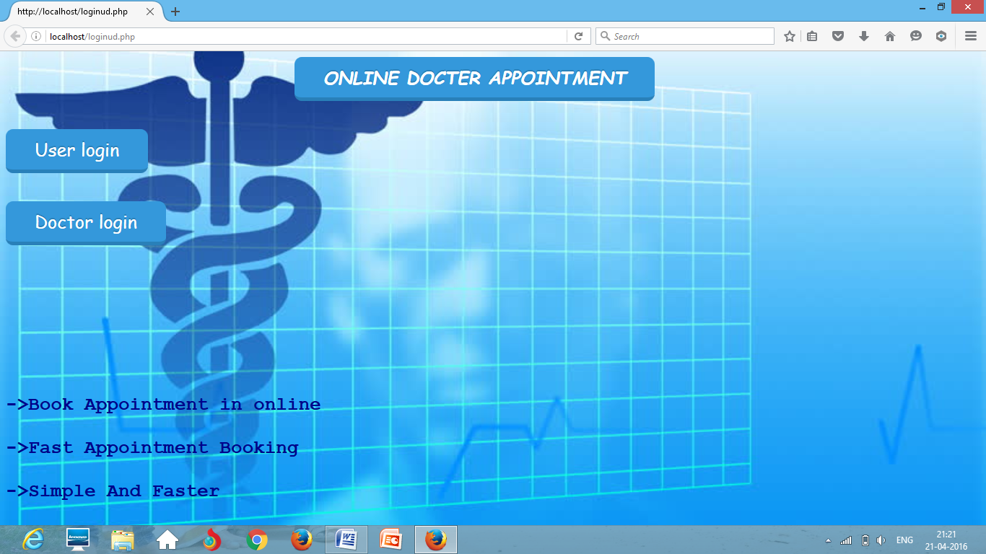

User login:

userlogin.php:

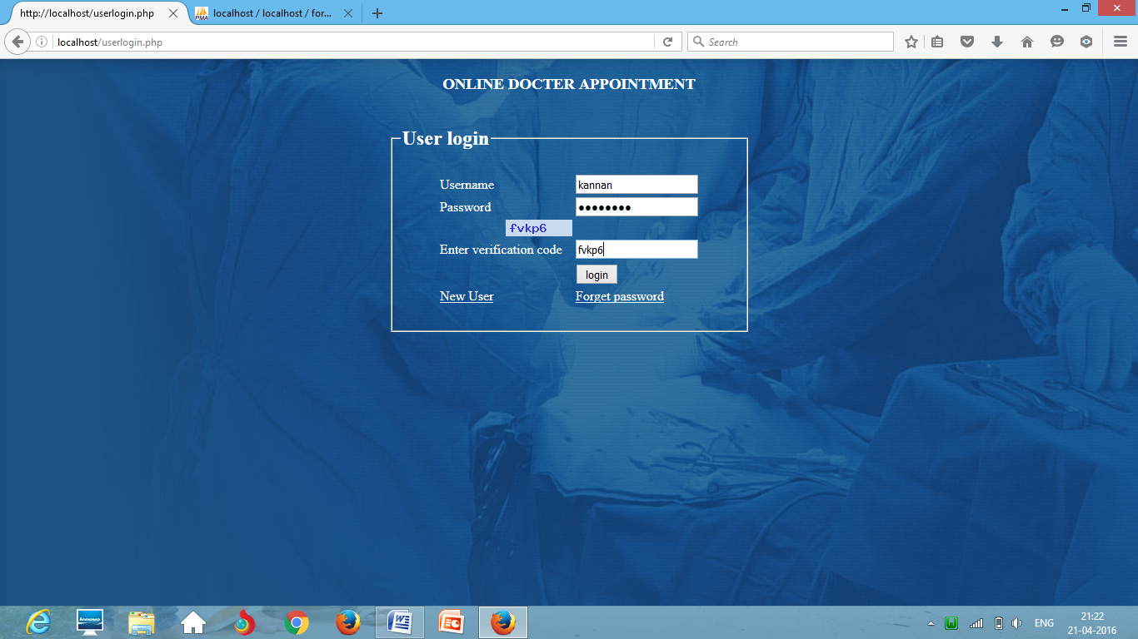

Selecting doctor:

welcomecopy.php

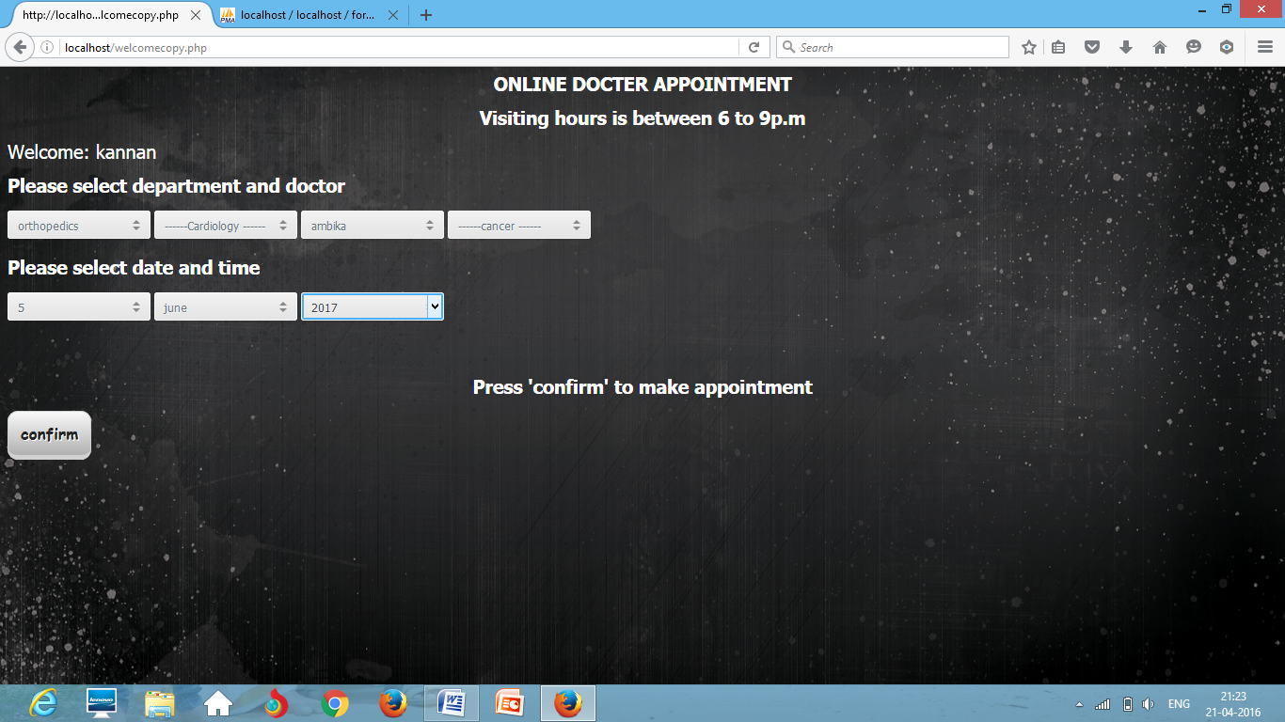

Appointment status:

confirm.php

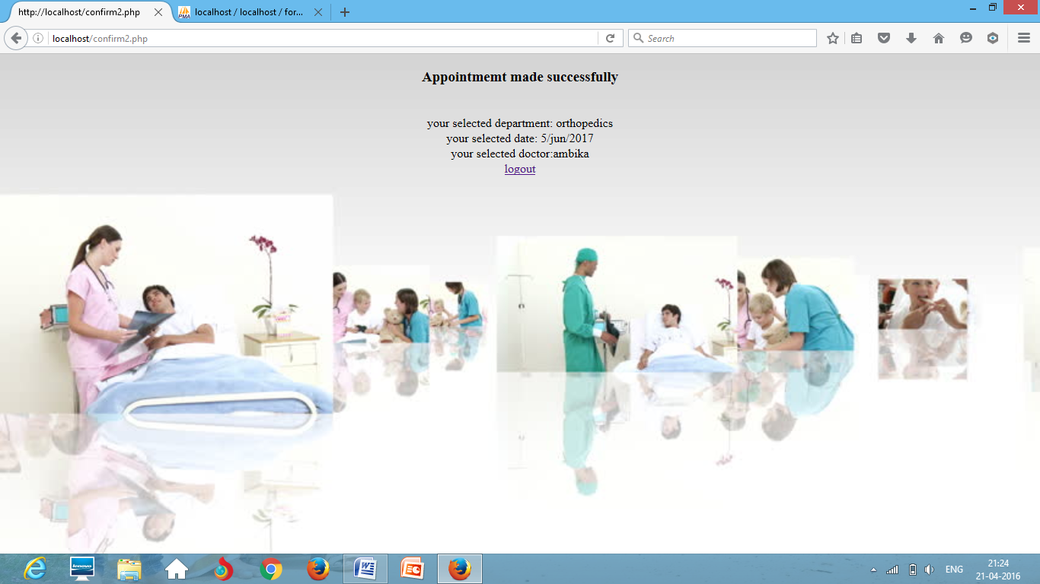

Doctor login:

doctorlogin.php

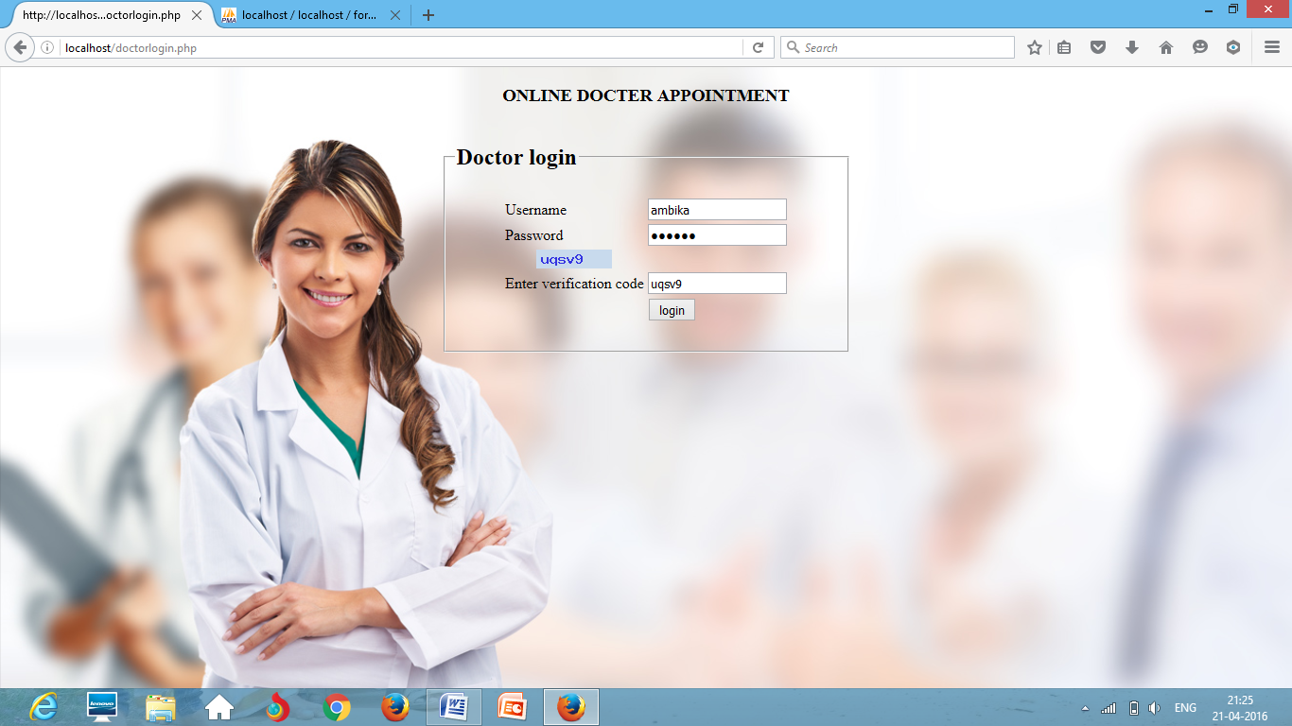

Patient details:

confirm2.php

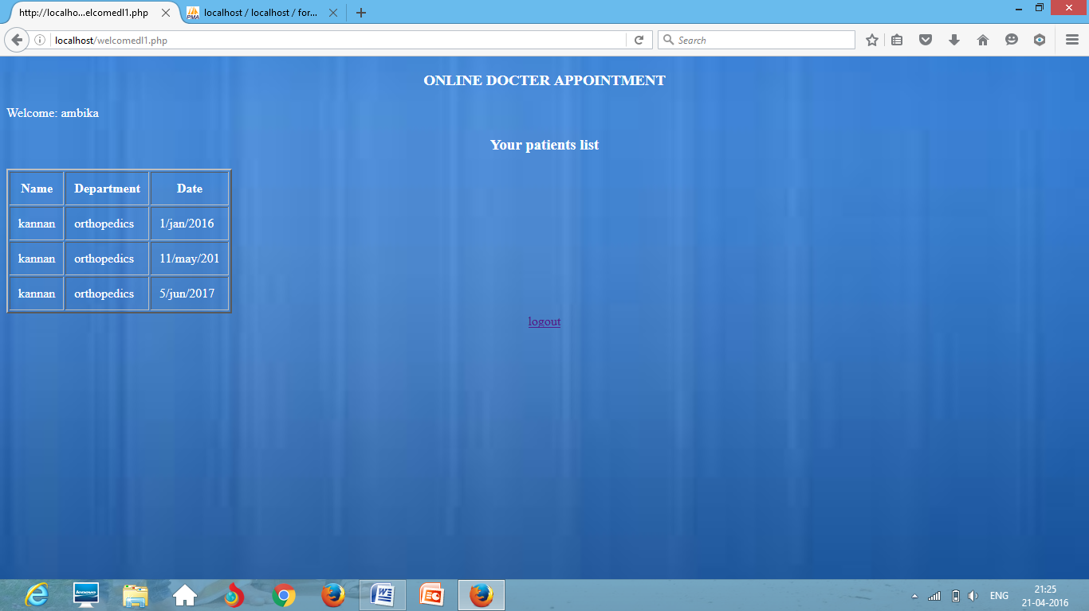

Forgot password:

reset5.php

sending password via sms to your registered phone number



New user registration form:

registration1.php

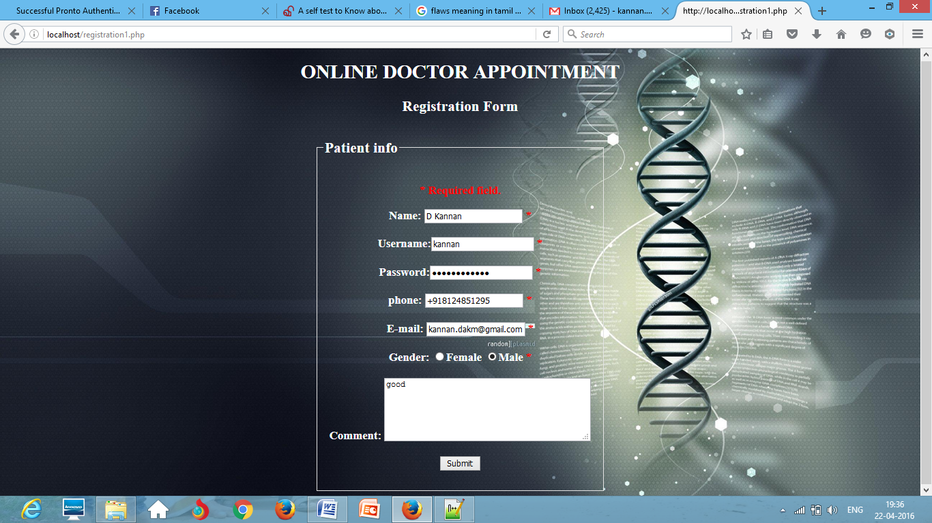

Registration confirmation page:

form3.php

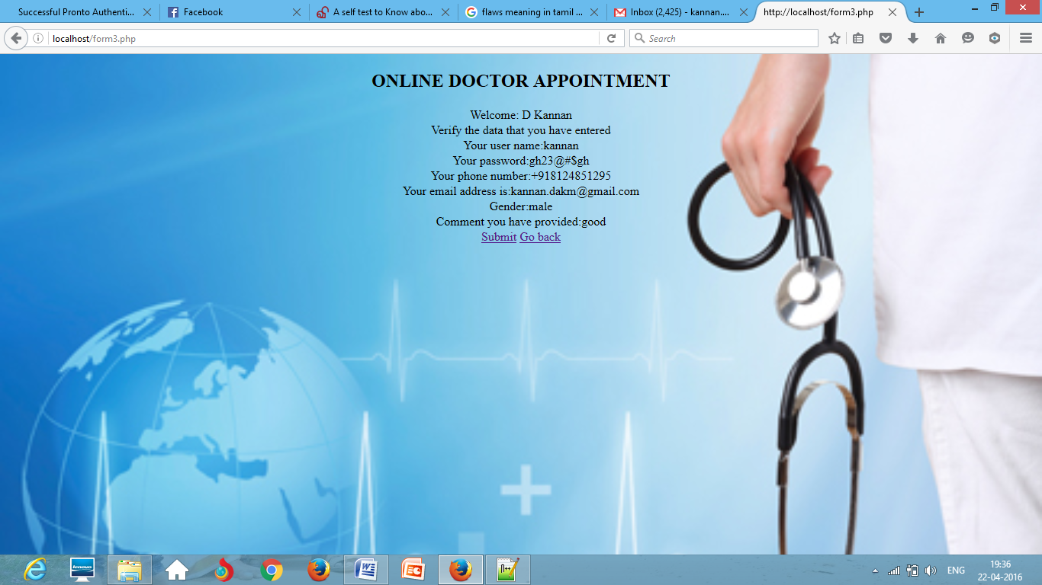

captcha1.php:generating the verification code

captcha2.php:validating the verification code

**CONCLUSION:**

Therefore I conclude that, this web application helps patients to easily make appointments to a particular doctor and to a particular department and they can also select a specific date. Even doctors can easily view their appointments with the patients.